Name: Kanishka S Roll no: 240701227

Comparative study of low-code development versus traditional application development approaches.

Aim:

To study and compare Low-Code Development and Traditional Application Development approaches based on development speed, cost, flexibility, maintenance, required skills, and overall efficiency in software development.

Introduction to traditional approach:

Traditional Application Development is the conventional method of building software applications by writing source code manually using programming languages such as Java, Python, C#, C++, and JavaScript. In this approach, developers perform each stage of the Software Development Life Cycle (SDLC), including requirement analysis, design, coding, testing, deployment, and maintenance.

Traditional development provides complete control over the application's functionality, architecture, and user interface, allowing developers to create highly customized and scalable solutions. It is widely used for complex enterprise systems, banking applications, e-commerce platforms, healthcare systems, and other applications that require high performance, security, and flexibility.

Although traditional development offers greater customization and control, it requires skilled developers, longer development time, and higher costs compared to modern low-code development approaches. Despite these challenges, it remains the preferred choice for building large-scale and mission-critical applications.

Introduction to low code approach:

Low-Code Development is a modern software development approach that enables applications to be built using visual interfaces, drag-and-drop components, pre-built templates, and minimal

manual coding. It simplifies the development process by allowing developers and even non-technical users (citizen developers) to create applications quickly and efficiently.

In a low-code platform, most application components are designed visually, while only a small amount of code is required for advanced customization and integrations. This approach reduces development time, lowers costs, and accelerates the delivery of applications.

Low-code development is widely used for business applications, workflow automation, customer management systems, and mobile or web applications. Popular low-code platforms include UiPath Apps, Microsoft Power Apps, Mendix, OutSystems, and Appian.

Although low-code platforms may offer less flexibility than traditional development, they provide faster development, easier maintenance, and quicker deployment, making them an attractive solution for organizations seeking rapid digital transformation.

Diagram for stages in traditional and low code:
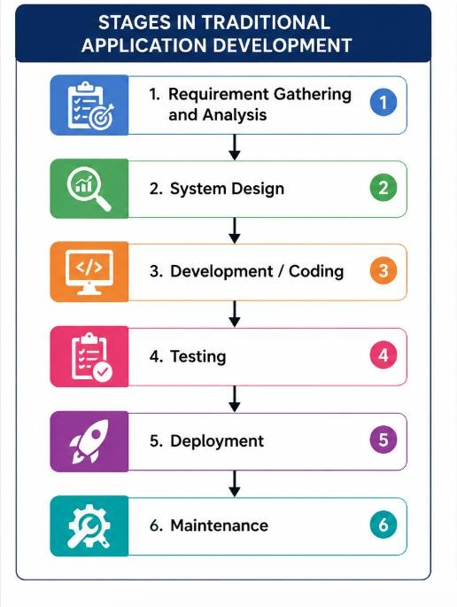

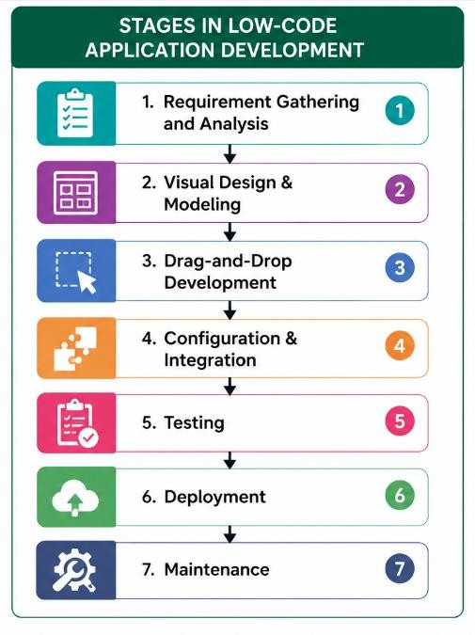

compare traditional and low code:

Aspect | Traditional Development | Low-Code Development
Definition | Applications are built by writing code manually. | Applications are built using visual tools with minimal coding.
Development Speed | Slower development process. | Faster development process.
Coding Requirement | Requires extensive coding. | Requires little or no coding.
Cost | Higher development and maintenance cost. | Lower development cost.
Developer Skills | Requires experienced programmers. | Can be used by both developers and citizen developers.
Customization | Highly customizable and flexible. | Limited customization compared to traditional development.

Aspect | Traditional Development | Low-Code Development
Scalability | Suitable for large and complex applications. | Best suited for small to medium business applications.
Maintenance | More complex and time-consuming. | Easier and quicker maintenance.
Testing Effort | Requires extensive testing. | Reduced testing effort due to pre-built components.
Time to Market | Longer time to deploy. | Faster deployment and delivery.
Security Control | Full control over security implementation. | Security depends partly on the platform provider.
Examples | Banking systems, ERP, E-commerce platforms. | Workflow automation, business apps, internal tools.

Result:
The study shows that low-code development enables faster and cost-effective application development with minimal coding, while traditional development offers greater flexibility and customization. The choice of approach depends on the project's complexity, budget, and development requirements.

